|  |  |  |  |  |  |  |  |  |
| --- | --- | --- | --- | --- | --- | --- | --- | --- |
|  |  |  |  |  |  |  |  |  |

**Question**

Suppose you are modeling the inventory level of a popular bike share location where customers may rent a bike for a period of time not exceeding the end of each day. Initially, there are 5 bikes at the location and 10 additional slots available for returns, for a total of 15 slots. Each day, there is a net loss or gain in inventory depending on the total number of customers who rent and return bikes, respectively, to the location. Over the next 7-day period, we will observe a daily number of requests that follows a Poisson distribution with a mean of 5 bikes and a daily number of returns that is equally likely between 0 and 10 bikes. You may assume that the returns and requests alternate throughout the day, beginning with a return (if applicable), until there is only one type of transaction (e.g., return, request, return, request, return, return). Note that customers who rent a bike from this location may return the bike to another location, and customers who rent a bike from other locations may return the bike to this location.

The inventory rebalancing policy is as follows: at the end of each day, the bike inventory must be between *s* and *S* bikes (*s* ≤ *S*). If the inventory is below *s*, bikes will be delivered to the location by the beginning of the next day so that the total inventory is *S* bikes. The delivery cost is a fixed $20 per day plus $2 per delivered bike, as they must be picked up from other locations. If the inventory is above *S*, bikes will be removed from this location by the beginning of the next day so that the total inventory is *s* bikes. The pickup cost is a fixed $20 per day, regardless of the number of bikes that need to be removed. If the inventory is within this range, no rebalancing of the bikes is performed. For the baseline scenario, (*s*, *S*) = (5, 10).

Customers who rent a bike from this location will generate revenue of $10 per rental. If a customer arrives to the location and there are no bikes available to rent, the location will incur a shortage cost of $10. If a customer arrives to return a bike to the location and there are no empty slots available, then the customer will have to return the bike to a nearby location, and the customer will be issued a $5 credit for the inconvenience.

1. Using @Risk and appropriate random variables for the number of requested and the number of received bikes each day, implement a simulation of the bike share inventory model over a 7-day period and track the end-of-day inventories, revenues, and various costs.
2. Run 1000 replications of the baseline scenario and report the distribution of total profit and the mean end-of-day inventory. In words, provide a basic description for each of these distributions.

After running 1000 replications of the baseline scenario the distribution of total profit is as follows:

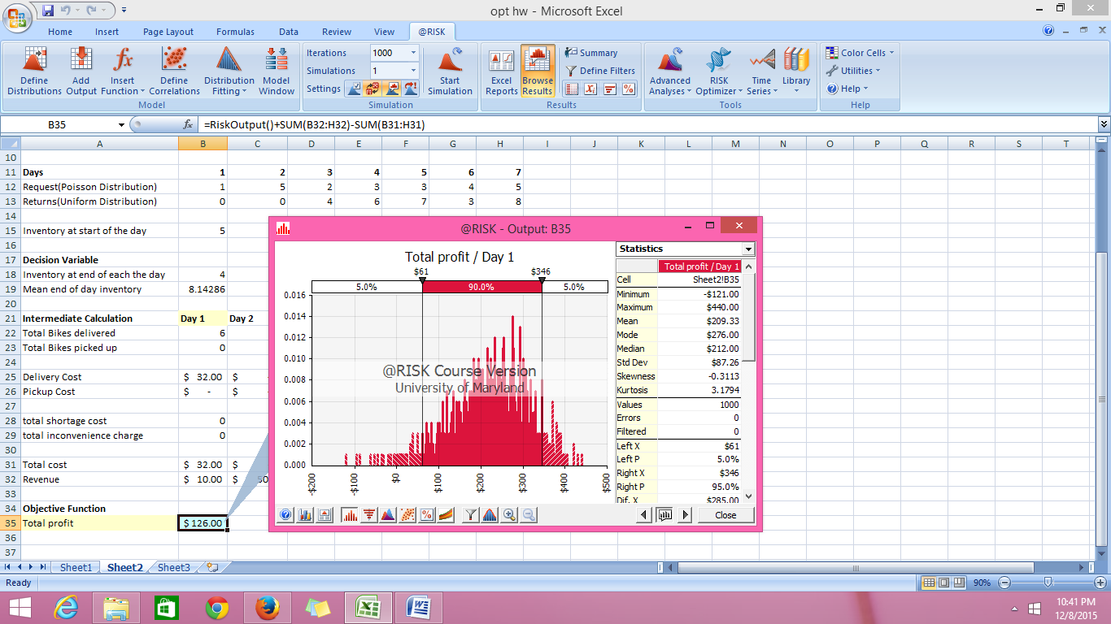

Mean total profit : $209.33

The distribution is more or less normal and slightly left skewed.

There is 90% chance that the total profit would lie between $61 to $346.

This means that there is fairly good chance that the total profit at the end of the week will be approximately $200.

After running 1000 replications of the baseline scenario the distribution of mean end of day inventory is as follows:

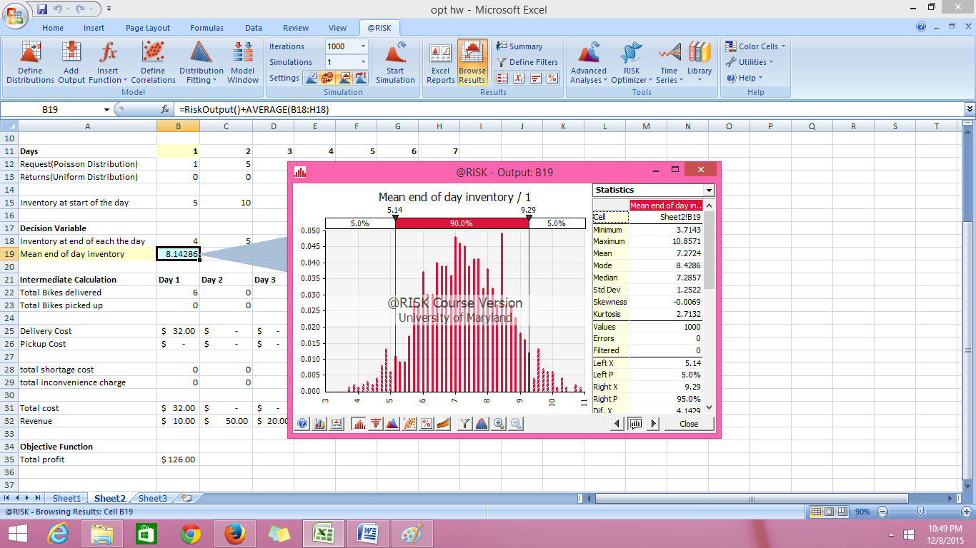

Mean end of day inventory: 7.2724.

The distribution is fairly normal.

There is 90% chance that the end of day inventory will be between 5.14 and 9.29.

This means that there is a fairly good chance that the mean end of day inventory for the week is around 7 bikes.

1. Explore a reasonable range of *s* to determine the optimal lower limit for the inventory policy. In a table, report appropriate statistics for the mean end-of-day inventory and total profit for each trial value of *s*. Then, report your selection for the optimal number for *s* along with the criteria you used to select this optimum.

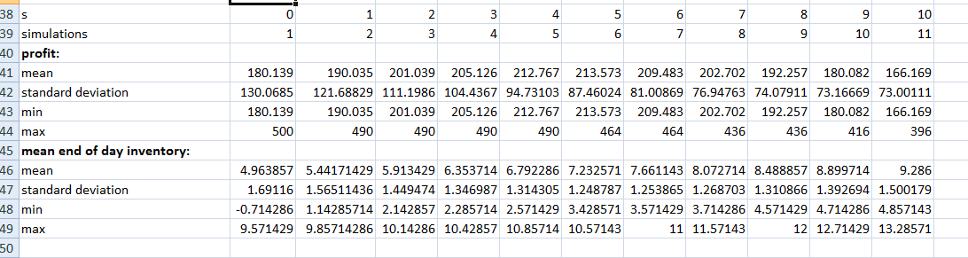

The explored range for‘s’ is between 0 to 10.

The above table consists of mean end of day inventory and total profit for all the‘s’ values.

**The maximum mean total profit ($213.573) through simulation is for s=5. Hence this could be the optimal lower limit for‘s’. The mean end of day inventory for s=5 is 7.23**

Mean end of day inventory is highest for s=10 (mean end of day inventory = 9.286), but the mean total profit is quite less ($166.169).